The film Men Beyond war
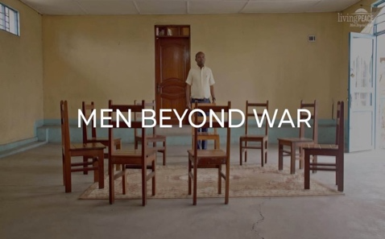

Men Beyond War (2022): is a film about traumatized men in Eastern Congo; about their challenges, recovery, their resilience, their hope, and ability to reintegrate into their families and communities. We see how these men - who lived through extreme hardship and war - try to break the vicious cycles of violence in group therapy sessions.
The film was made for Living Peace Institute in Goma with financial support from the Ministry of Foreign Affairs of the Netherlands, and is used for community screenings in the Democratic Republic of Congo to talk about trauma and violence.

Living Peace Institute (LPI) is a Congolese non-profit organization dedicated to promoting mental and psychosocial health of people in conflict areas to restore peace and stability. LPI targets men and boys, in addition to girls and women, conducts research, provides education and training, and implements psychosocial support groups in Congo and other countries ravaged by conflict and war in Africa and the Middle East.

Background
Research

Equimundo in collaboration with local researcher partners in eastern DRC carried out the International Men and Gender equality Survey (IMAGES) research on the effects of war on men conducted in Rwanda, DRC and in a demobilization center for ex-combatants in Rwanda between 2010-2014.
These studies highlighted links between perceptions around masculinities, mental health and psychosocial problems of men and intersecting cycles of violence at home and in communities. Results from those studies revealed the impact of men’s traumatization as one of the missing pieces in peacebuilding, as a well as a key factor contributing to men’s subsequent use of physical and psychological violence against female partners and their children, and self-harm.

The Living Peace Institute (LPI) was born in part out of this research. Established in Goma as a Congolese NGO in 2015, LPI has reached more than 3 million people living in conflict-affected based Eastern DRC with an evidence-based proven positive impact on reduction of violence and improved mental health outcomes for men and their families. The Living Peace methodology integrated insights from the IMAGES studies on masculinities and gender relations in the context of Eastern DRC- and framed within its cultural traditions and political realities- in a trauma-focused therapeutic model aiming to prevent men’s violence against women and support men’s coping in the backdrop of the conflict in Eastern DRC.

The initiative – Living Peace – was framed with the belief that healing from trauma should be centered on addressing the obstacles to reintegrating fragmented and isolated parts of the individual’s psyche after experiencing and witnessing violence by encouraging men to question or reduce their belief in the hegemonic masculinist norms that keep them from seeking help, forming healthy connections, allow them to deny trauma and that drive cycles of violence. As such the approach combines aspects of community-based psychosocial support groups (IASC, 2007) that are focused on coping with adversity and trauma (IASC 2012, UNHCR 2013, DeJong 2015) together with gender-transformative group education with men based in part of Equimundo’s years of experience with its Program H approach. Over the years of implementation, the model evolved into a healing-centered peacebuilding approach in order to address the legacies of collective trauma, enabling peace on a societal level (Volkan, 2013, Tankink et al 2017, Hübl, 2020 Yoder, 2022).

Since 2015, the Living Peace model has been adapted for youth and adults and implemented in various conflict-affected countries and high-violence settings, including in northern Cameroon, in the Kurdish region of Iraq, with Syrian refugees in Lebanon, and in the US with youth in settings affected by high rates of homicides.

Living Peace model: localization of findings in a context-appropriate model.
LPI is using a bottom-up, group therapeutic approach to address men’s traumatization as a source of violence against women next to men’s involvement in other forms of interpersonal and community-based violence. Omnipotent self-perceptions of men are addressed as protection shields of men, to hold on social norms of manhood to be in control and power. Self-protection mechanism of men in the Congolese culture also serve to defend deep rooted injuries and collective traumas since colonialism, transmitted over generations. Unraveling omnipotent self-perceptions on masculinities, require self-reflection in quality interpersonal relationships to help recognize traces of trauma and to adopt alternative ways of dealing with being man, and defend failure. By targeting men as the primary vectors of change, LPI addresses numerous expert recommendations to not focus exclusively on women when working to prevent SGBV. Interestingly, numerous positive side effects of the intervention as improved mental health and self-control control and made the intervention applicable for working with men in the security sector as will be explained below.

The underlying socio-ecological model is core in LPI’s theory of change. Building on the ecology of the violence model of the WHO (2002), insights on collective trauma legacies (Volkan, 2006, Buhl, 2022) and insights from systematic therapy. LP uses this systematic therapeutic approach by giving living systems (as groups of men, family, youth, or community groups) nudges that help them to develop new patterns.

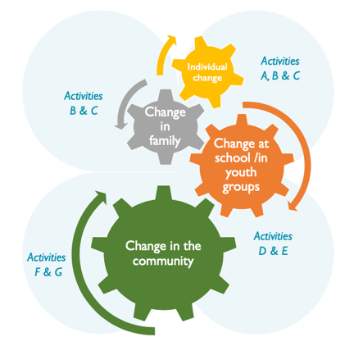
Source: LPI ecological model

How does it work?
Living Peace groups are organized in the communities with fifteen men per group, meeting weekly for three hours sessions during 12-15 weeks. The sessions, facilitated by community lay persons, take place in the community, and are facilitated by trained community facilitators, who are guided by a detailed described and well-structured manual with information, exercises, and topics for each of the fifteen sessions. LPI participants and facilitators are identified in partnership with local community leaders and security sector officials, who are trained to identify those most likely to benefit from psychosocial group therapy. In doing so, they remind men of Bazra, a traditional local conflict resolution mechanism where community men sit together to resolve problems and conflicts. During the 15 weeks, spouses, family members, neighbours and community members are step by step getting involved.
LPI encourages participation by emphasizing confidentiality and volunteerism, and its training modules are targeted to all different categories of participants, including non-violent men. Since 2015, more than 10,000 men, and spouses, families, and neighbours in more than 50 communities in Nord and South Kivu and Ituri participated in Living Peace groups.

The impact
A qualitative impact evaluation of the Living Peace program (supported by the World Bank and the Sexual Violence Research Initiative) (Tankink et al. 2017) found that three years after the intervention, positive changes among men, their families, and their communities continued, including reduction in alcohol abuse, improved conflict management among couples, adoption of more gender-equitable attitudes, reduction in violence against female partners, and improved household economic outcomes.
Two evaluations carried out for EKN (Embassy of the Kingdom of the Netherlands) by different consultant firms (INFOCUS in 2018 and ADE in 2022) confirmed the long-lasting positive results as found earlier: violence reduction, improved social and family cohesion, improved support of men to women in the households, better health, and economic conditions at individual and family levels. In the community, the team (2022) detected increased awareness related to gender equality, positive masculinity, and condemnation of SGBV, positive effects on security personnel regarding SGBV prevention, improved professional ethical performance in police and army, and improved relations with the civilian population. (www.Government.nl)
A Cluster Randomized Controlled Trial study was carried out between 2018-2021 aiming to determine whether LPint reduces domestic violence due to mediating effects of reduction of psychopathology, improved positive masculinity attitudes, family and social life and psychological states. The results showed a significant decrease of PTSD symptoms, and substance abuse in the case group compared to the control group in both males and females. During post-intervention, the level of mental wellbeing, perceived social support and general self-efficacy were substantially increased in participants from the case group compared to those from the control group in both males and females. Of interest, there were relatively few statistically significant differences observed between case and control immediately after the intervention (endline1); but many were observed at endline 2, 1.5 years after the intervention.
The Living Peace intervention is unique because it works with the perpetrators to change their violent behaviors. This breaks the cycle of violence directly (I.e., the men are less violent) and indirectly (i.e., influence their children and their wider community). The studies done so far provide clear evidence that LPint has an impact on the participating men and their families in terms of reducing violence use against women. Mental health and psychosocial support contribute to peacebuilding, because men’s wounds of war, as ticking bombs of new conflicts, are healed. Further research is needed on MHPSS and peacebuilding and the role of men and boys in this, next to those of women and girls.
In our years of working with men in the DRC and other conflict-affected areas, we are convinced that we must: (1) acknowledge the collective impact of trauma that goes beyond individuals, (2) identify and name men’s trauma, (3) understand how cultural-specific constructions of masculinities affect trauma and (4) offer men-next to women- a social space to make sense of their trauma, meaning that communities and social service systems support and encourage men to seek support for trauma. Demining land of anti-personnel mines is, as is demining the minds of men in conflict settings, slow and painstaking; it often takes years of careful attention. And it is ultimately a collective responsibility.

https://www.equimundo.org/resources/masculinity-and-gender-based-violence-in-rwanda-experience-and-perceptions-of-men-and-women/
https://www.equimundo.org/resources/gender-relations-sexual-and-gender-based-violence-and-the-effects-of-conflict-on-women-and-men-in-north-kivu-eastern-drc-results-from-images/
https://www.equimundo.org/resources/a-study-of-gender-masculinities-and-reintegration-of-former-combatants-in-rwanda-results-from-images/
https://www.government.nl/documents/reports/2023/01/31/endline-evaluation-of-the-living-peace-project

