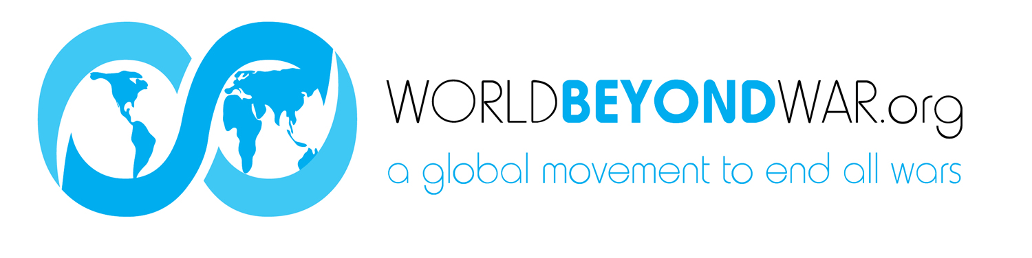
I understand that wars and militarism make us less safe rather than protect us, that they kill, injure and traumatize adults, children and infants, severely damage the natural environment, erode civil liberties, and drain our economies, siphoning resources from life-affirming activities. I commit to engage in and support nonviolent efforts to end all war and preparations for war and to create a sustainable and just peace.

NAME EMAIL ADDRESS ZIPCODE

_________________________________________________________________________________________________________________________

_________________________________________________________________________________________________________________________

_________________________________________________________________________________________________________________________

_________________________________________________________________________________________________________________________

_________________________________________________________________________________________________________________________

_________________________________________________________________________________________________________________________

_________________________________________________________________________________________________________________________

_________________________________________________________________________________________________________________________

_________________________________________________________________________________________________________________________

_________________________________________________________________________________________________________________________

_________________________________________________________________________________________________________________________

_________________________________________________________________________________________________________________________

_________________________________________________________________________________________________________________________

_________________________________________________________________________________________________________________________

_________________________________________________________________________________________________________________________

Please photograph completed form and email to greta@worldbeyondwar.org or mail the form to
World BEYOND War P.O.Box 1484 Charlottesville VA 22902 USA. THANKS!

