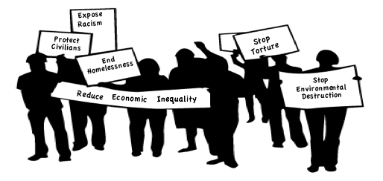

WorldBeyondWar.org

Contact: [info@worldbeyondwar.org](mailto:info@worldbeyondwar.org)

[](https://www.facebook.com/worldbeyondwar/) [](https://twitter.com/WorldBeyondWar) [](https://www.youtube.com/worldbeyondwar)

Go to **WorldBeyondWar.org**

to get Involved:

[Sign the Declaration of Peace](http://worldbeyondwar.org/individual/)

[Help Pass Local Resolutions](http://worldbeyondwar.org/resolution/)

[Attend our Events](http://worldbeyondwar.org/eventsforWBW/)

[The Abolish War Campaign](http://worldbeyondwar.org/abolish/)

[Divest from Weapons Dealers](http://worldbeyondwar.org/divest/)

War can be ended if met by popular resistance!

Modern day wars will become increasingly more destructive with the advancement of politics without principles, industry without morals, and science without ideals.