

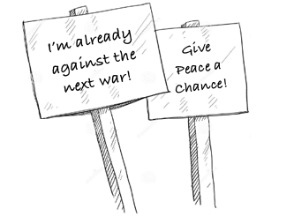

Go to **WorldBeyondWar.org**

to get Involved:

[Sign the Declaration of Peace](http://worldbeyondwar.org/individual/)

[Help Pass Local Resolutions](http://worldbeyondwar.org/resolution/)

[Attend our Events](http://worldbeyondwar.org/eventsforWBW/)

[The Abolish War Campaign](http://worldbeyondwar.org/abolish/)

[Divest from Weapons Dealers](http://worldbeyondwar.org/divest/)

War can be ended if met by popular resistance!

WorldBeyondWar.org

Contact: [info@worldbeyondwar.org](mailto:info@worldbeyondwar.org)

[](https://www.facebook.com/worldbeyondwar/) [](https://twitter.com/WorldBeyondWar) [](https://www.youtube.com/worldbeyondwar)

Modern day wars will become increasingly more destructive with the advancement of politics without principles, industry without morals, and science without ideals.